1. Write program to find whether a given year is a leap year or not.

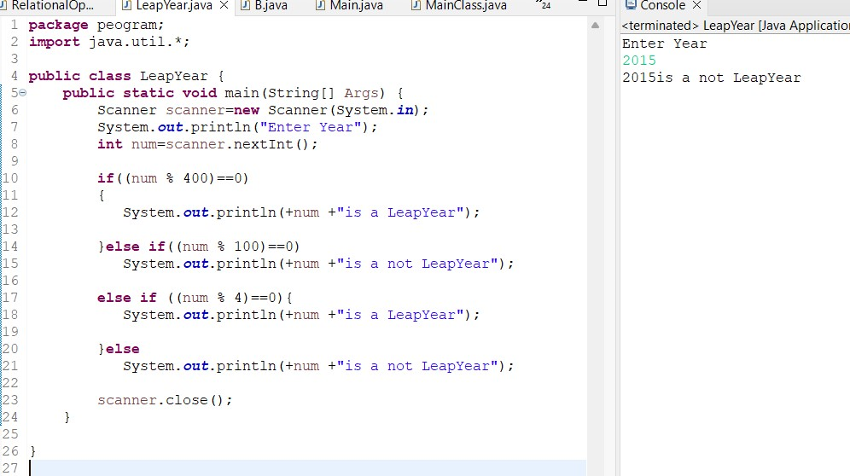

1. program to read roll no, name and marks of three subjects and calculate the total, percentage and division  
   Test Data :  
   Input the Roll Number of the student :784  
   Input the Name of the Student :James  
   Input the marks of Physics, Chemistry and Computer Application : 70 80 90  
   Expected Output :  
   Roll No : 784  
   Name of Student : James  
   Marks in Physics : 70  
   Marks in Chemistry : 80  
   Marks in Computer Application : 90  
   Total Marks = 240  
   Percentage = 80.00  
   Division = First

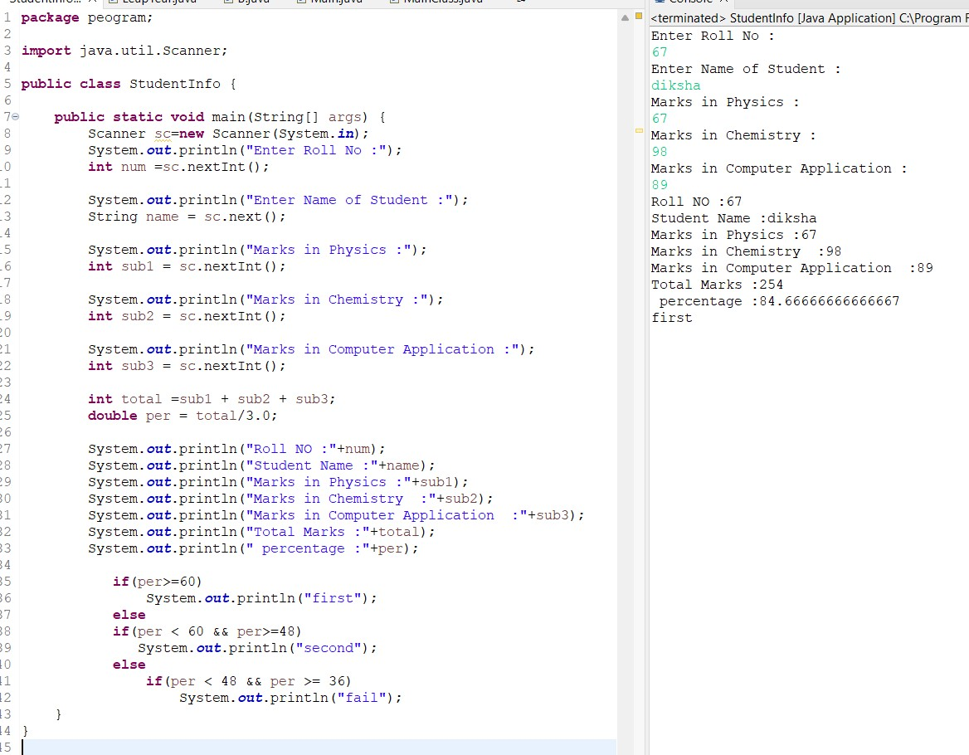

1. program to read temperature in centigrade and display a suitable message according to temperature state below : [Go to the editor](https://www.w3resource.com/c-programming-exercises/conditional-statement/index.php#editorr)  
   Temp < 0 then Freezing weather  
   Temp 0-10 then Very Cold weather  
   Temp 10-20 then Cold weather  
   Temp 20-30 then Normal in Temp  
   Temp 30-40 then Its Hot  
   Temp >=40 then Its Very Hot  
   Test Data :  
   42  
   Expected Output :  
   Its very hot.

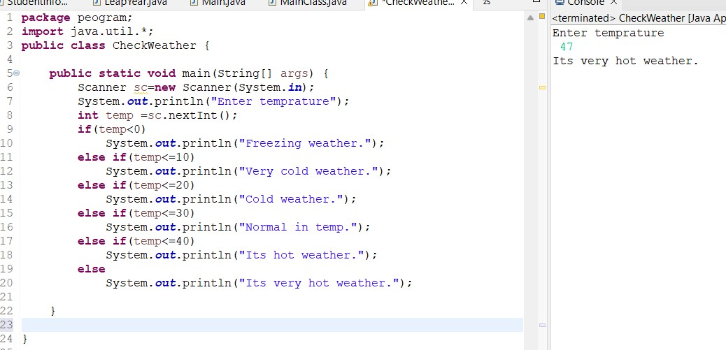

1. program to check whether a character is an alphabet, digit or special character.

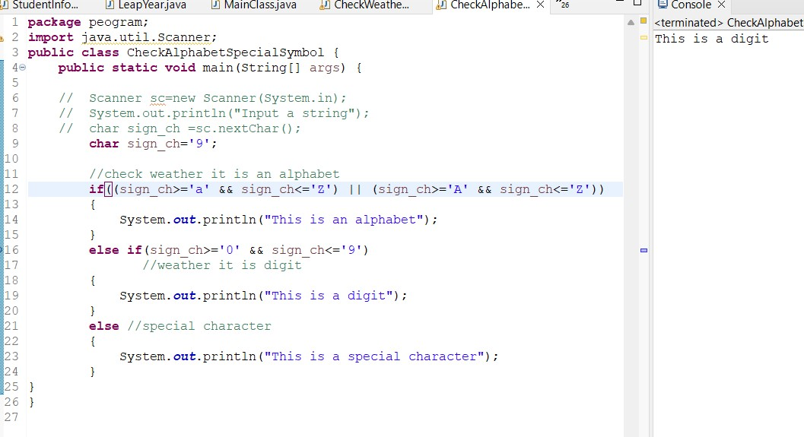

1. Write a program in to accept a grade and declare the equivalent description

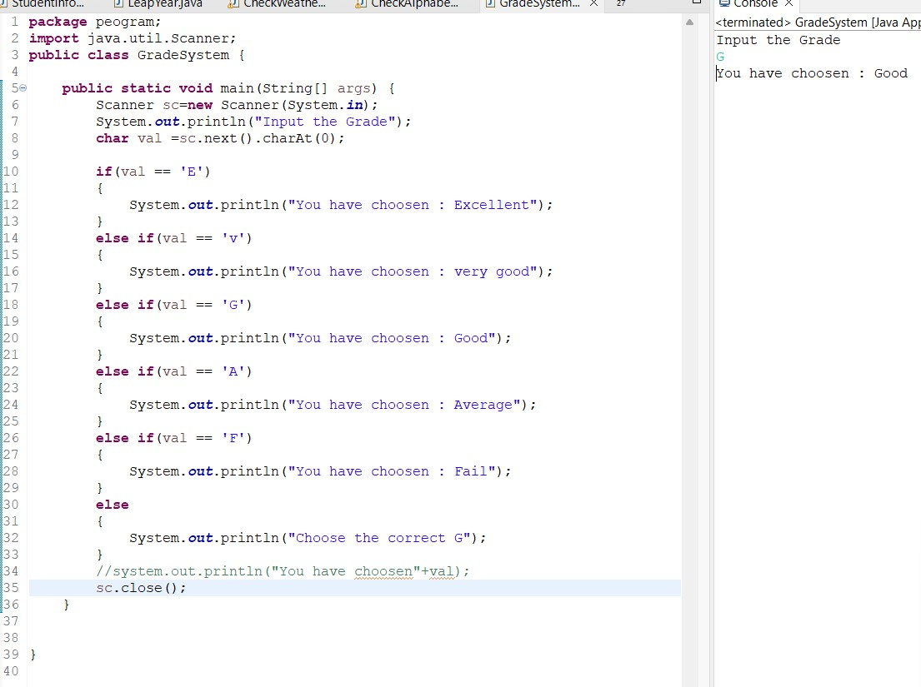

1. Write a program in java to read any day number in integer and display day name in the word.

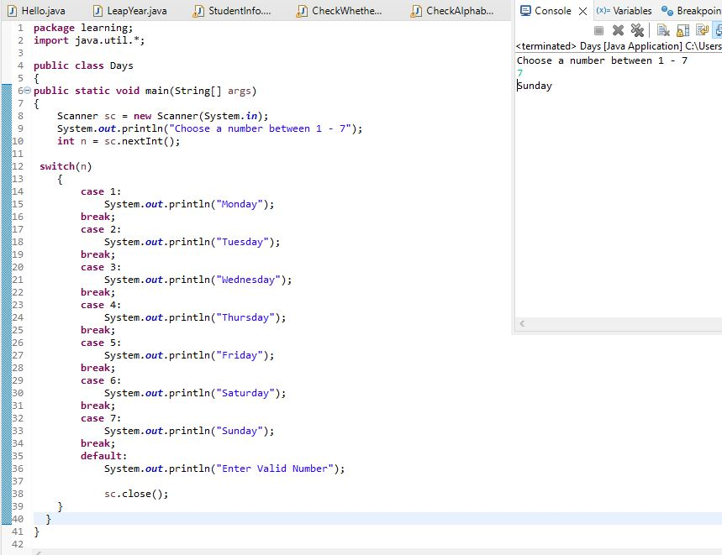

7.read any Month Number in integer and display the number of days for this month.

